

*Web Technologies I*

*TERM PROJECT*

**TOUR-FOR-LIFE**

INSTRUCTOR: **Mrs. Simrandeep Kaur**

**Date: 3 April, 2019**

**S**TUDENT **N**AME: **MANPREET SINGH SANDHU (747450)**

**PARAMJEET KAUR (747429)**

**RAMANPREET KAUR (748669)**

**HARMANDEEP SINGH (747624)**

**SECTION 1:**

1. **PURPOSE OF WEBSITE:**

* The main objective of the project is to provide knowledge to the people who want to have a travel and tourism in Toronto, ON.
* To promote client’s business over the internet.
* To make people aware of services provided by client.
* To design a user friendly efficient computerized Tour Management System.
* A flexible system which can maneuver the customer-staff relationship in an effective manner.
* To provide better graphical user interface.
* Computerization of a Tour booking can be helpful as means of saving time & money.
* To share the information over traveling with friends and family and making their experience worthy.
* To Build Reputation, Generating Lead and Nurturing Sales in world of tourism.

1. **THE TARGET AUDIENCE:**

This website will target all ages from children to senior citizens, who are willing to travel in various parts of the Toronto. As in this modern world, exploring the places has become a neglected part of our daily life. Due to this materialistic scenario people use to be couch potato. As they are so busy in their daily routine that they are unable to manage their time for visiting tourist places. This website encourages them to take a step, towards desired tourist places.

1. **PAGES IN WEBSITE:**

There are five pages in website:

1. **Home**: This page Provides a brief overview to the user about the tourism. It Allows the user to explore the various tourist places in Toronto. It also contains some fun activities which is organised by us.
2. **Places:** This page contains the information about various places which are tourist attraction in Toronto Ontario. In order to know about why these places are popular a brief description is present there with article, quotes, images and audios of previous trips.
3. **Activities:** It is our personal experience that, in order to enjoy the trip, there is need to do some fun activities with them, with whom we are travelling. It requires a personal attention of customer. Activities like horse-riding, ballooning, off-roading, pool party etc.
4. **Book tour:** This page includes a form for user to book their touronline. Theycan select the places, where they want to go. It just a simple form to get the user information, if seats will be available then user will get a User message of confirmationthat your seat is booked.
5. **Offers:** This page shows the offers which is provided by our company to users that makes our website more popular among people because offers include discount, free kid-meal, free tickets and many more.
6. **About:** This page includes the basic knowledge about company including Background of company, problems solved by our client along with their way of helping.
7. **Contact:** This section contains information for the user in order to maintain contact with company along with its location and working hours. A contact form in this allows user to directly contact to the executives of company and share their views.
8. **GRAPHICS USED IN WEBSITE:**

A logo was developed by one of our team-member.

This is a multimedia site contains Text, Videos and Images.

Most of pictures used are **royalty free.** In case if licensed media is used, its proper reference and copyright status has been maintained.

1. **COLORS USED IN WEBSITE:**

The colors used in website are: Blue, Black, Red, White, Green, Purple, Yellow, Orange, Violet, Silver, Gold, Gray, Pink, Fuscia, Light Blue, Sky blue, Aqua, Khaki.

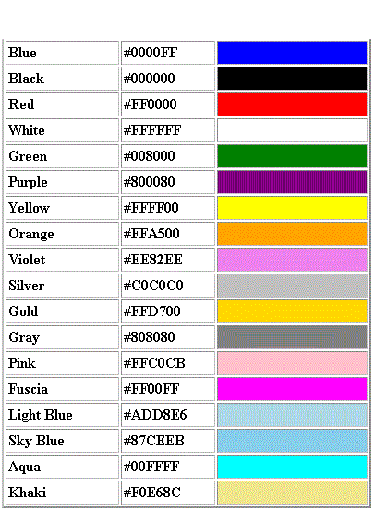

1. **FONT STYLES USED IN WEBSITE:**

The fonts used in website are:

1. Serif
2. sans-serif
3. Calibri
4. Verdana
5. Arial
6. Georgia
7. Times New Roman
8. **FEATURES DISPLAYED IN THE WEBSITE:**

* **Web page contain: -**

HTML5 semantic elements - Meta tags - Links - Images - Block and Inline content - Forms with basic validation - Tables - Headings - Paragraphs – Lists.

* Fluid layout - Media queries - Flexible images - Box model.
* It contains form.
* Popup modals.
* Text and font styling.
* Everything is done without using the **Javascript.**

1. **REFERENCES:**

The following sites has been referred for the content used in the website, while construction of the website and their link has been provided along with them.

* Wikipedia: <https://www.wikipedia.org/>

**9.VALIDATION:**

The validation of CSS and HTML files has been done using the following sites:

* CSS validator: <https://jigsaw.w3.org/css-validator/>
* HTML validator: https://validator.w3.org/

**SECTION 2:**

**Site Map:**

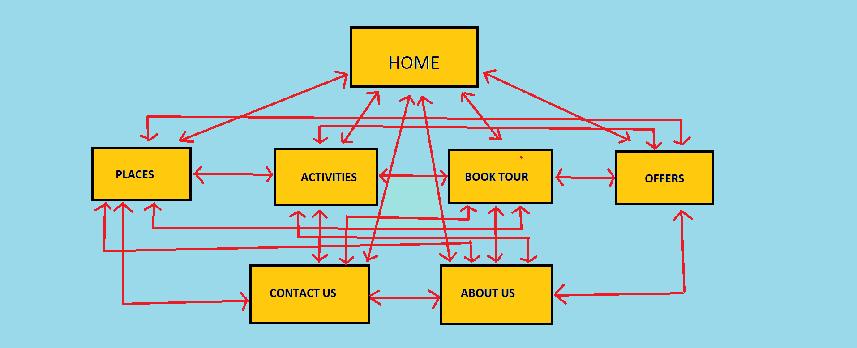

**WIREFRAME FOR DESKTOP:**

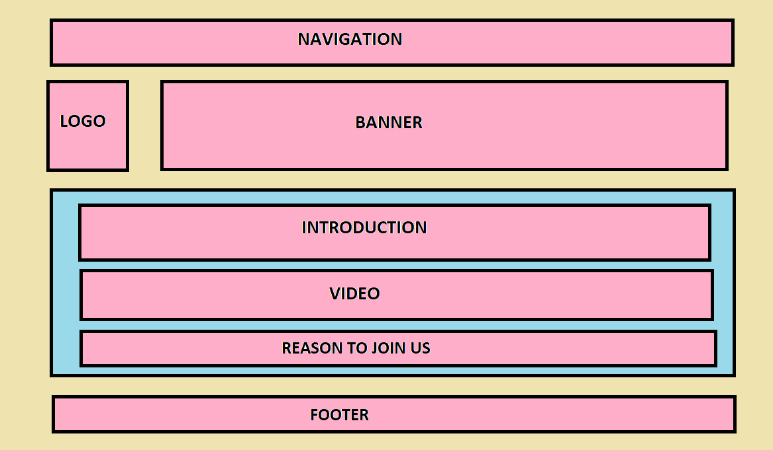

**WIREFRAME FOR TABLET:**

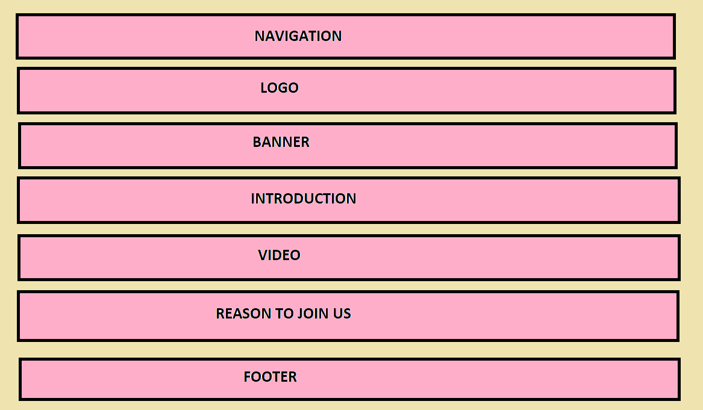

**WIREFRAME FOR MOBILE VIEW:**

